**Amplitude Modulation**

The amplitude of the carrier signal varies in accordance with the instantaneous amplitude of the modulating signal.” Which means, the amplitude of the carrier signal containing no information varies as per the amplitude of the signal containing information, at each instant.

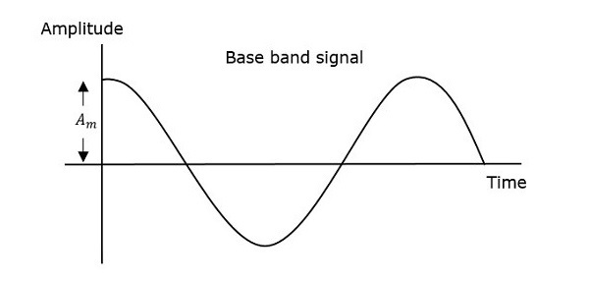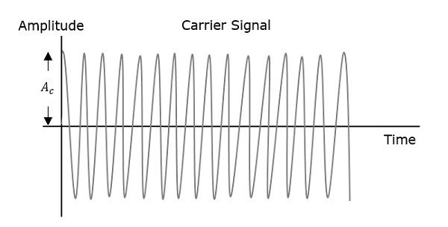

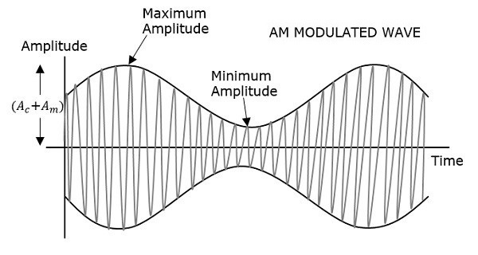

The first figure shows the modulating wave, which is the message signal. The next one is the carrier wave, which is a high frequency signal and contains no information. While, the last one is the resultant modulated wave.

It can be observed that the positive and negative peaks of the carrier wave, are interconnected with an imaginary line. This line helps recreating the exact shape of the modulating signal. This imaginary line on the carrier wave is called as Envelope. It is the same as that of the message signal.

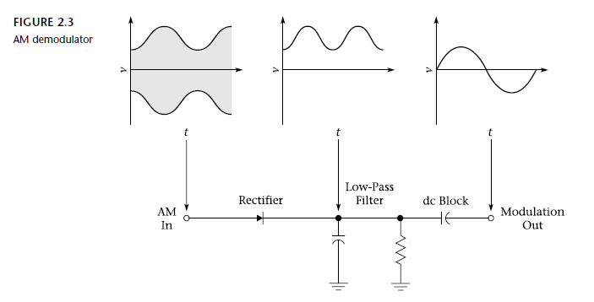

Mathematical Expressions

Following are the mathematical expressions for these waves.

Time-domain Representation of the Waves

Let the modulating signal be,

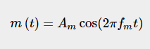

and the carrier signal be,

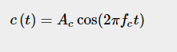

Where,

  are the amplitude of the modulating signal and the carrier signal respectively.

are the frequency of the modulating signal and the carrier signal respectively.

Then, the equation of Amplitude Modulated wave will be

 (Equation 1)

**Modulation Index**

The ratio between the amplitudes of the modulating signal and the carrier is

defined as the modulation index, µ. Mathematically,

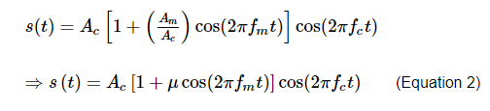.



Now, let us derive one more formula for Modulation index by considering Equation 1. We can use this formula for calculating modulation index value, when the maximum and minimum amplitudes of the modulated wave are known.

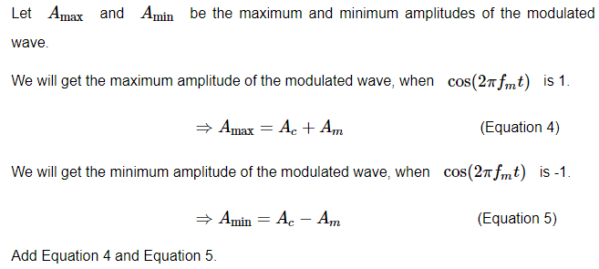

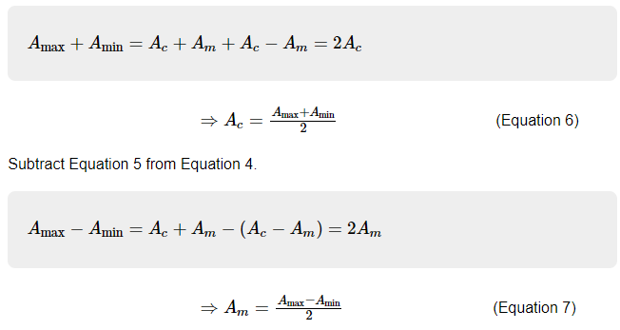

The ratio of Equation 7 and Equation 6 will be as follows.

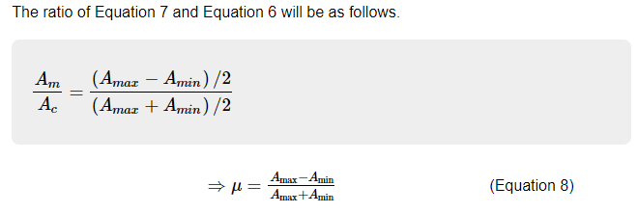Therefore, Equation 3 and Equation 8 are the two formulas for Modulation index. The modulation index or modulation depth is often denoted in percentage called as Percentage of Modulation. We will get the percentage of modulation, just by multiplying the modulation index value with 100.

For a perfect modulation, the value of modulation index should be 1, which implies the percentage of modulation should be 100%.

For instance, if this value is less than 1, i.e., the modulation index is 0.5, then the modulated output would look like the following figure. It is called as Under-modulation. Such a wave is called as an under-modulated wave.

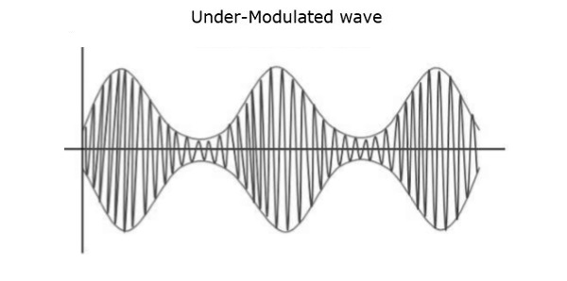

If the value of the modulation index is greater than 1, i.e., 1.5 or so, then the wave will be an over-modulated wave. It would look like the following figure.

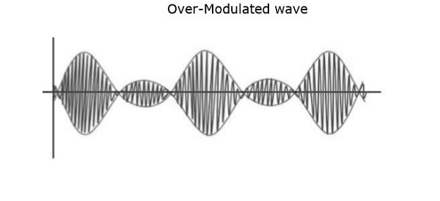

As the value of the modulation index increases, the carrier experiences a 180o phase reversal, which causes additional sidebands and hence, the wave gets distorted. Such an over-modulated wave causes interference, which cannot be eliminated.

Bandwidth of AM Wave

Bandwidth (BW) is the difference between the highest and lowest frequencies of the signal. Mathematically, we can write it as

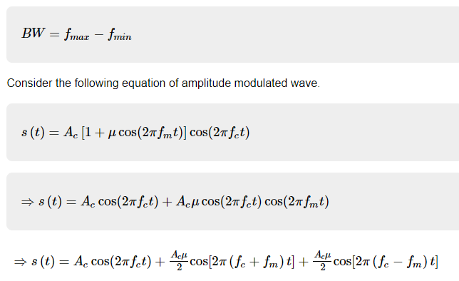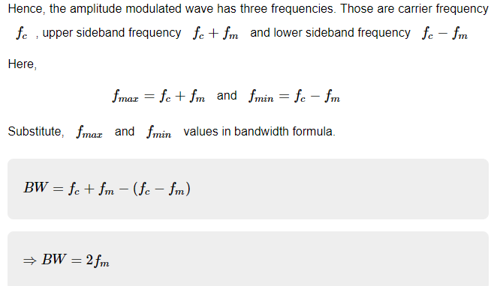Thus, it can be said that the bandwidth required for amplitude modulated wave is twice the frequency of the modulating signal.

**Power Calculations of AM Wave**

Consider the following equation of amplitude modulated wave.

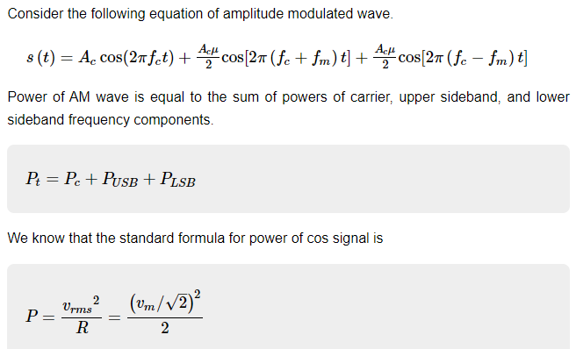

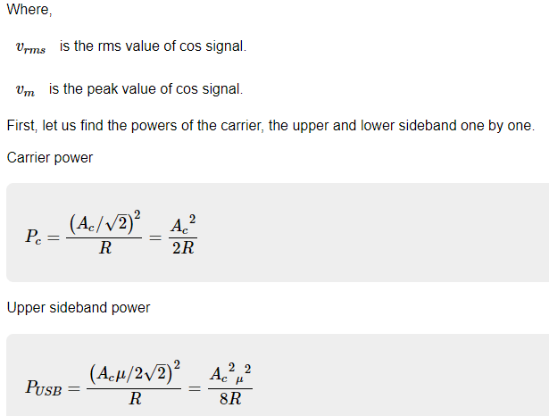

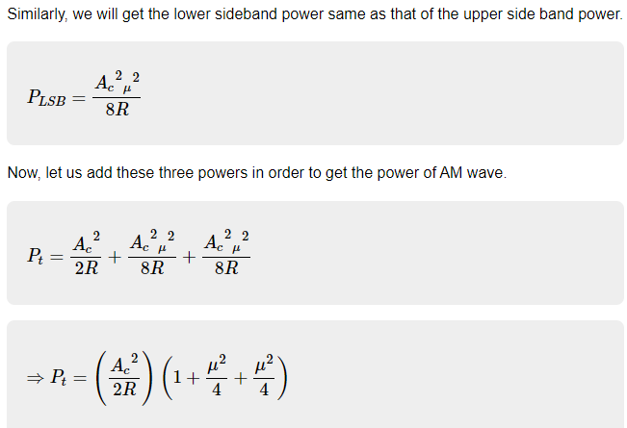

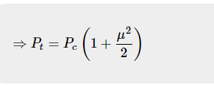

We can use the above formula to calculate the power of AM wave, when the carrier power and the modulation index are known.

If the modulation index μ=1, then the power of AM wave is equal to 1.5 times the carrier power. So, the power required for transmitting an AM wave is 1.5 times the carrier power for a perfect modulation.